10-4: Correlated Subqueries

Try It / Solve It

1. Explain the main difference between correlated and non-correlated subqueries?

В некоррелируемых запросах результаты внутренного запроса вычисляются первыми и используются дальше во внешнем запросе.

Коррелируемые запросы выполняются по нескольку раз для каждой строки результата внешнего запроса, а лишь затем выполняется.

1. Write a query that lists the highest earners for each department. Include the last_name, department_id, and the salary for each employee.

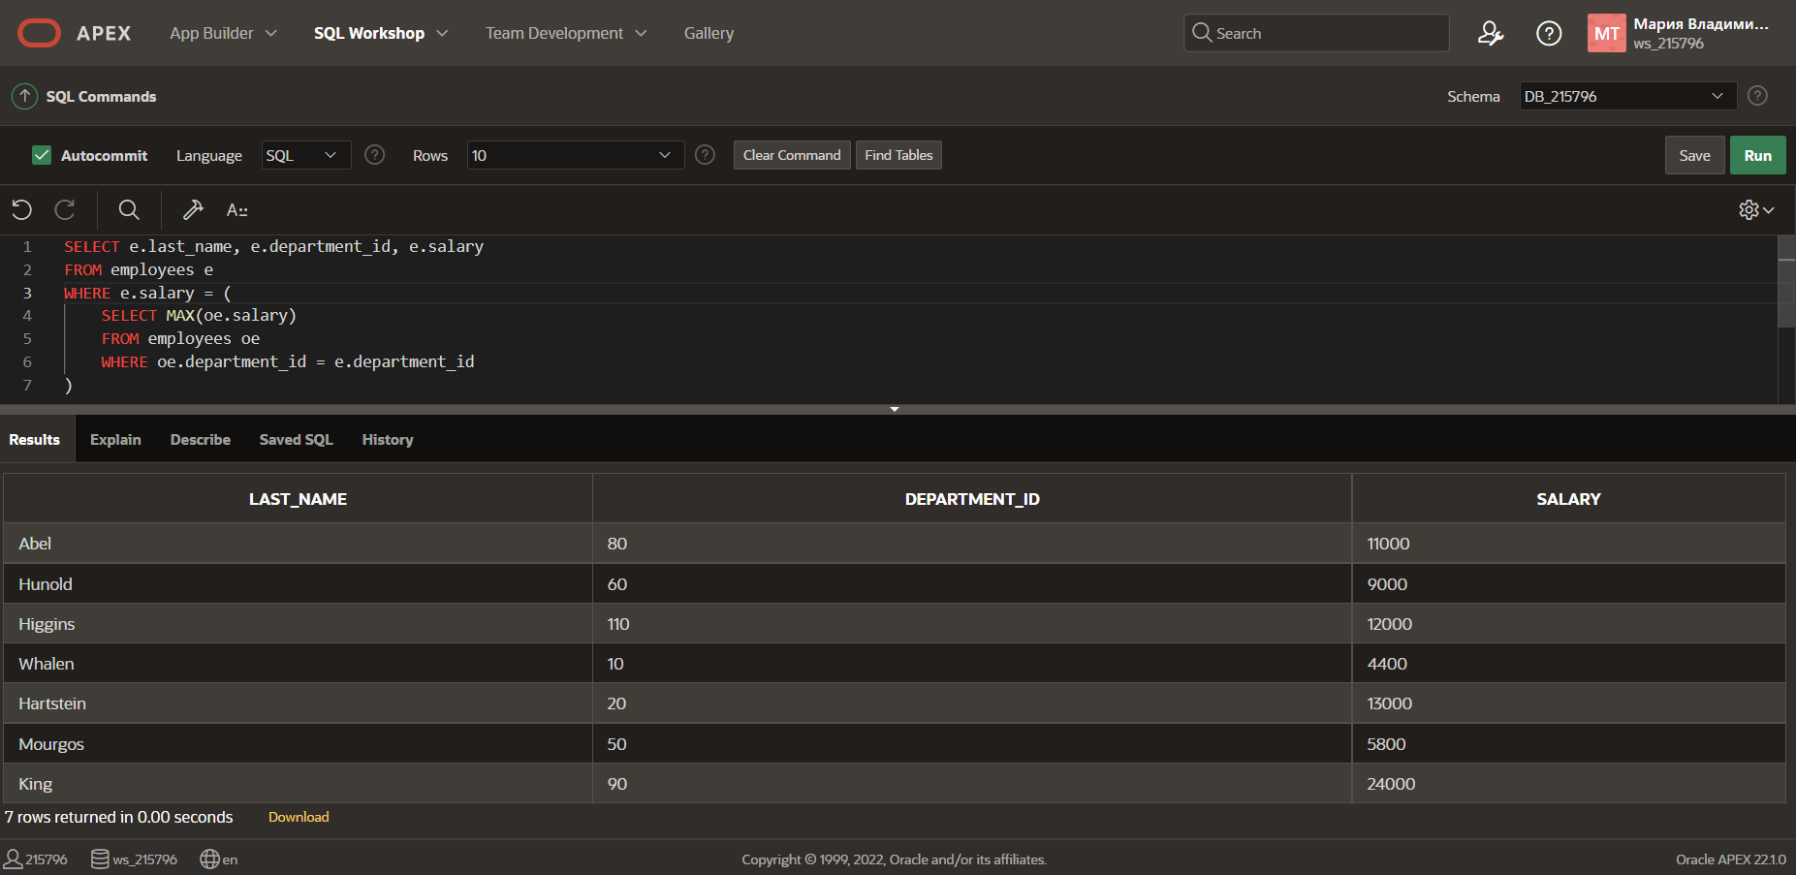

1. Examine the following select statement and finish it so that it will return the last_name, department_id, and salary of employees who have at least one person reporting to them. So we are effectively looking for managers only. In the partially written SELECT statement, the WHERE clause will work as it is. It is simply testing for the existence of a row in the subquery.

SELECT (enter columns here)

FROM (enter table name here) outer

WHERE 'x' IN (SELECT 'x'

FROM (enter table name here) inner

WHERE inner(enter column name here) = inner(enter column name here)

Finish off the statement by sorting the rows on the department_id column.

1. Using a WITH clause, write a SELECT statement to list the job_title of those jobs whose maximum salary is more than half the maximum salary of the entire company. Name your subquery MAX_CALC_SAL. Name the columns in the result JOB_TITLE and JOB_TOTAL, and sort the result on JOB_TOTAL in descending order.

Hint: Examine the jobs table. You will need to join JOBS and EMPLOYEES to display the job_title.